Galaxy Buds Live

SM-R180NZNAMEA

[**Product Ratings :4.3(Number of Ratings :3227)**](javascript:void(0))

* Ergonomic design
* Active Noise Cancellation for open type
* Live and deep sound

**Looking for alternatives?**

[[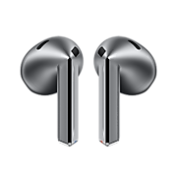](https://www.samsung.com/pk/audio-sound/galaxy-buds/galaxy-buds3-silver-bluetooth-sm-r530nzaamea/)](https://www.samsung.com/pk/audio-sound/galaxy-buds/galaxy-buds3-silver-bluetooth-sm-r530nzaamea/)

[**Galaxy Buds3**](https://www.samsung.com/pk/audio-sound/galaxy-buds/galaxy-buds3-silver-bluetooth-sm-r530nzaamea/)

**Rs. 51,999.00**

[Product Ratings :2.1](https://www.samsung.com/pk/audio-sound/galaxy-buds/galaxy-buds3-silver-bluetooth-sm-r530nzaamea/#reviews)

[**Learn more**](https://www.samsung.com/pk/audio-sound/galaxy-buds/galaxy-buds3-silver-bluetooth-sm-r530nzaamea/)

[[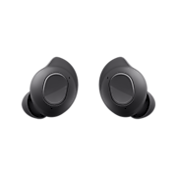](https://www.samsung.com/pk/audio-sound/galaxy-buds/galaxy-buds-fe-graphite-sm-r400nzaamea/)](https://www.samsung.com/pk/audio-sound/galaxy-buds/galaxy-buds-fe-graphite-sm-r400nzaamea/)

[**Galaxy Buds FE**](https://www.samsung.com/pk/audio-sound/galaxy-buds/galaxy-buds-fe-graphite-sm-r400nzaamea/)

**Rs. 33,399.00**

[Product Ratings :4.7](https://www.samsung.com/pk/audio-sound/galaxy-buds/galaxy-buds-fe-graphite-sm-r400nzaamea/#reviews)

[**Learn more**](https://www.samsung.com/pk/audio-sound/galaxy-buds/galaxy-buds-fe-graphite-sm-r400nzaamea/)

Choose your color

**Color :**Mystic Bronze

**Galaxy Buds Live**

Mystic Bronze

[**Where to buy**](javascript:;)

key features

* 

Iconic design

* 

Color

* 

Ergonomic

* [**Galaxy  
  Note20 | 20Ultra**](https://www.samsung.com/pk/smartphones/galaxy-note20/)
* [**Galaxy  
  Buds Live**](https://www.samsung.com/pk/audio-sound/galaxy-buds/galaxy-buds-live-mystic-bronze-sm-r180nznamea/)
* [**Galaxy  
  Watch3**](https://www.samsung.com/pk/watches/galaxy-watch/galaxy-watch3-41mm-mystic-silver-sm-r850nzsamea/)

Galaxy Buds Live



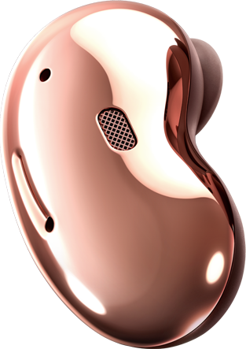

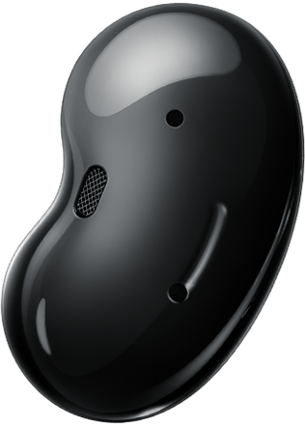

**Introducing Galaxy Buds Live**

The earbud designed to tune in to every moment. With an iconic shape and ergonomic design, a fit that lets in your natural surroundings, and a speaker optimized for a better experience. This is sound made for your ears.

A design that's unheard of

ICONIC DESIGN

The new iconic shape of true wireless earbuds

Galaxy Buds Live’s eye-catching design stands out, even inside your ear. Reflecting the curves of the ear and face for a natural look, they're polished off with a glossy finish and even come together with a jewelry box-inspired case — to fit in your hand when on the go.

Galaxy Buds Live in Mystic Bronze are shown from the sides, and as they rotate the screen zooms out to show the two together.

COLOR

Elevate your style with glossy finishes

Available in three colorways you can't help but love. Choose from Onyx, Mystic Bronze, Mystic White, Mystic Black, Mystic Red or Mystic Blue to add a flashy touch to your look.[1](https://www.samsung.com/pk/audio-sound/galaxy-buds/galaxy-buds-live-mystic-bronze-sm-r180nznamea/#desc-section)

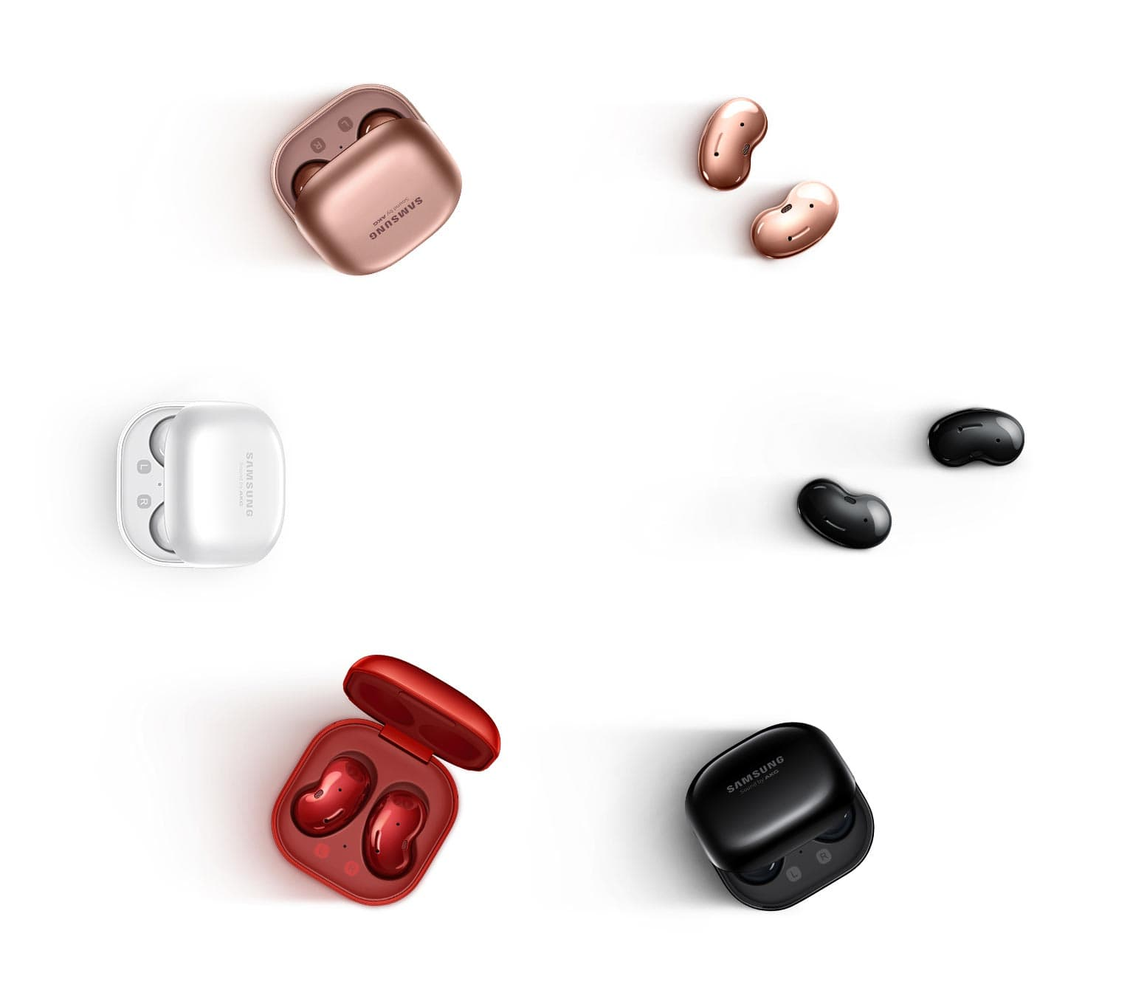

ERGONOMIC

Made for your ears

Galaxy Buds Live sit softly inside the ear, giving you a fit for all-day comfort with less fatigue. Its ergonomic design is snug yet non-intrusive with two wing tip sizes for a better fit. So, commute to the office, go to a friend's house, and more without your buds leaving your ears.



Stay tuned in

ACTIVE NOISE CANCELLATION

What you hear is up to you



ANC OFFANC ON

The first Active Noise Cancellation (ANC) for open type on Galaxy’s true wireless buds keeps the noise out, but lets the world in. It reduces background noises without missing what’s important, like voices and announcements, so you hear more of what you want to hear — all with just a long press to turn it on.[2](https://www.samsung.com/pk/audio-sound/galaxy-buds/galaxy-buds-live-mystic-bronze-sm-r180nznamea/#desc-section)



*Active Noise Cancellation (ANC) on Galaxy Buds Live received UL Verification for cutting background noise by up to 97% in low-frequency bands.

LIVE & DEEP SOUND

Hear every sound come alive

Feel like you're in the front row, or part of something bigger. 12mm speakers with sound by AKG work together with Galaxy Buds Live's ergonomic design to deliver spacious sound, while the large driver and bass duct help emit deep bass with air flow that lets sound flow seamlessly.

**Air ventsreduce occlusion for spacious audio**

**12mm speakerwith sound by AKG for clear notes, high or low**

**Bass ductenhances lower frequency sound**

Make an easier connection

BIXBY VOICE WAKE-UP

A smart assistant who listens back

Bixby voice wake-up is ready whenever you call. It wakes up to your voice, letting you control your phone without lifting a finger. Manage your calls, adjust the volume, or check weather while on the move. You talk, Bixby listens.[3](https://www.samsung.com/pk/audio-sound/galaxy-buds/galaxy-buds-live-mystic-bronze-sm-r180nznamea/#desc-section),[4](https://www.samsung.com/pk/audio-sound/galaxy-buds/galaxy-buds-live-mystic-bronze-sm-r180nznamea/#desc-section),[5](https://www.samsung.com/pk/audio-sound/galaxy-buds/galaxy-buds-live-mystic-bronze-sm-r180nznamea/#desc-section)

*Image simulated for illustrative purposes.





360 AUDIO

Go deep into your entertainment - 360 Audio

360 Audio delivers a remarkable cinema-like sound. With Dolby Head Tracking™ technology you'll feel as though you're in the center of the stage fully surrounded by sound. It's a powerful and dramatic listening experience, and with Dolby Atmos®, you'll hear everything in stunning detail.

*Available only on Samsung Galaxy smartphones and tablets with Android One UI version 3.1 or later. 360 Audio and Dolby Head Tracking™ support may vary depending on app and content.



A set of Mystic Bronze Galaxy Buds Live slides to the center of the screen, with the left side appearing from the bottom left corner and the right side appearing from the top right. As they meet in the middle, they rotate as a pair 360 degrees to reveal all aspects of both sides. When they stop, the inside portion of the left side faces directly forward to reveal the L and various speaker and mic components. The right side is angled slightly to face the left side.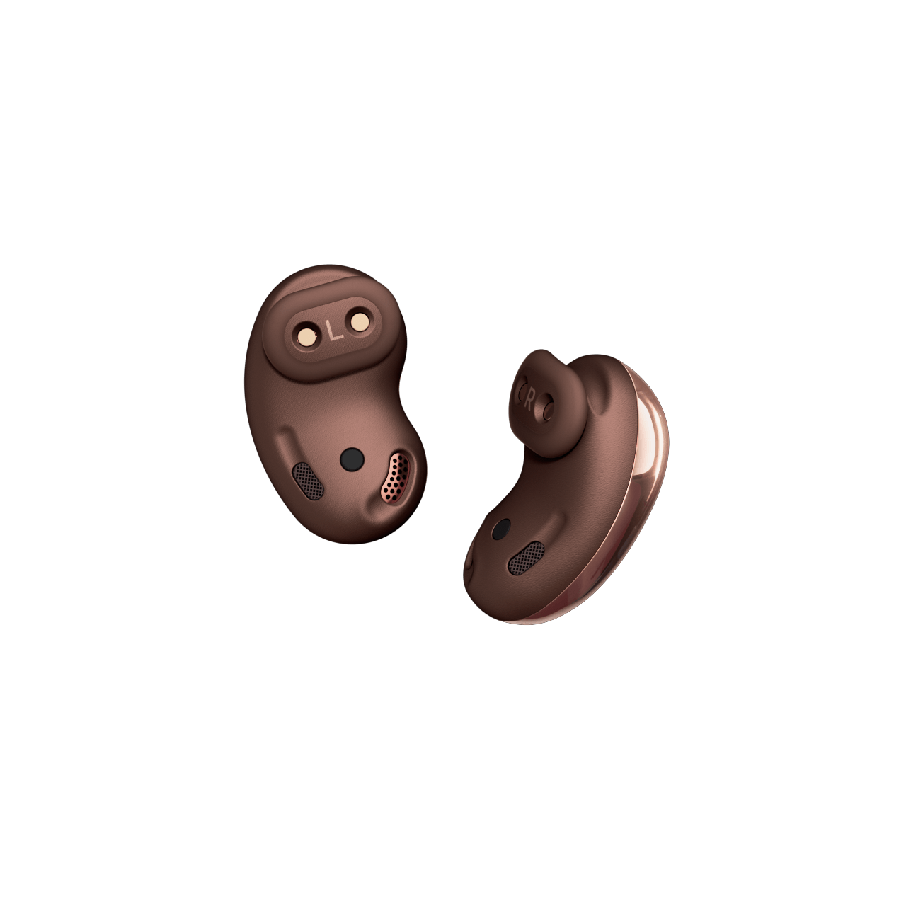

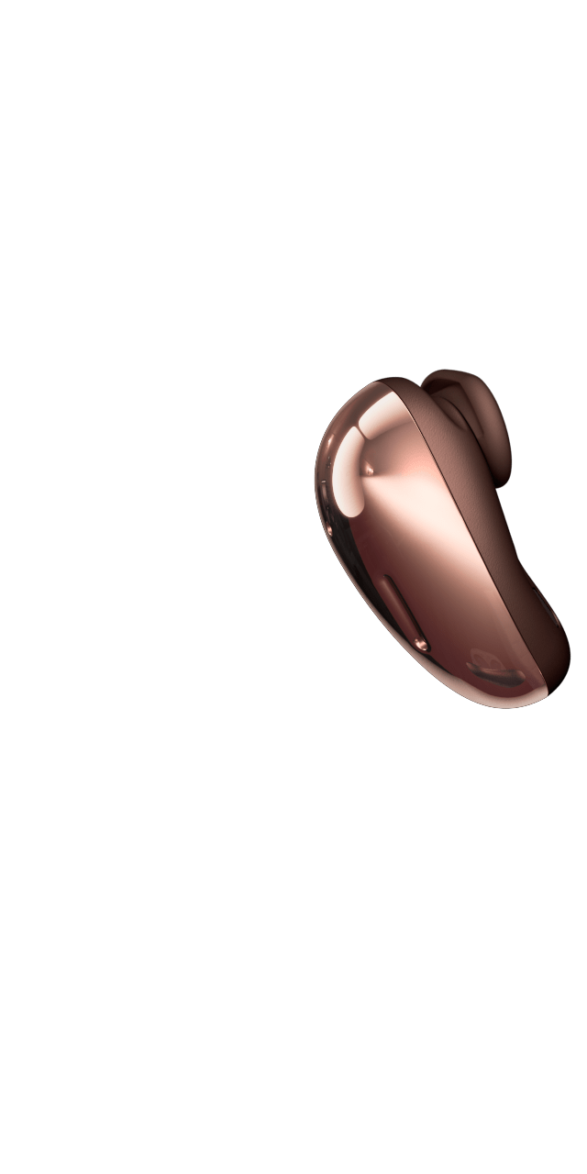

SPOTIFY

Touch and hold, and Spotify plays

Galaxy Buds Live’s Spotify integration lets you assign a shortcut on your phone. Touch and hold for one second to instantly connect to all your favorite playlists. It’s easy listening. Half a million podcasts and 50 million songs are now at your fingertip.[6](https://www.samsung.com/pk/audio-sound/galaxy-buds/galaxy-buds-live-mystic-bronze-sm-r180nznamea/#desc-section),[7](https://www.samsung.com/pk/audio-sound/galaxy-buds/galaxy-buds-live-mystic-bronze-sm-r180nznamea/#desc-section),[8](https://www.samsung.com/pk/audio-sound/galaxy-buds/galaxy-buds-live-mystic-bronze-sm-r180nznamea/#desc-section)

*Requires configuring touchpad settings through the Galaxy Wearables app.